EMOTIONS DETECTION THROUGH SPEECH

**Hamid Rehman**

**Muhammad Danish**



DEPARTMENT OF COMPUTER SCIENCES

COMSATS UNIVERSITY ISLAMABAD, VEHARI CAMPUS

VEHARI – PAKISTAN

SESSION 2017-2021

EMOTIONS DETECTION THROGH SPEECH

*Undertaken By:*

**HAMID REHMAN**

Reg. No. CIIT/FA17-bCS-121/Vhr

**MUHAMMAD DANISH**

Reg. No. CIIT/FA17-bCS-058/Vhr

*Supervised By:*

**JAWAD RAFIQ**



A DISSERTATION SUBMITTED AS A PARTIAL FULFILLMENT OF THE REQUIREMENTS FOR THE DEGREE OF BACHELORS IN COMPUTER SCIENCE / SOFTWARE ENGINEERING

DEPARTMENT OF COMPUTER SCIENCES

COMSATS UNIVESITY ISLAMABAD, VEHARI CAMPUS

VEHARI – PAKISTAN

SESSION 2017-2021

**CERTIFICATE OF APPROVAL**

It is to certify that the final year project of BS (CS) “EMOTIONS DETECTION THROUGH SPEECH” was developed by **HAMID REHMAN(CIIT/FA17-BCS/121)** and **MUHAMMAD DANISH (CIIT/FA17-BCS/058)** under the supervision of “JAWAD RAFIQ” and that in his opinion; it is fully adequate, in scope and quality for the degree of Bachelors of Science in Computer Sciences.

---------------------------------------

**Supervisor**

---------------------------------------

**External Examiner**

---------------------------------------

**Head of Department**

**(Department of Computer Science)**

**DEDICATION**

To Almighty ALLAH and the Holy Prophet Muhammad (P.B.U.H)

&

To my Loving Parents and Teachers

**ACKNOWLEDGEMENT**

All praise to Almighty Allah alone, the Omnipotent, the most compassionate. His prophet “MUHAMMAD” (peace be upon him), the most perfect and exalted among and of ever born on the surface of the earth, who is forever torch of guidance and knowledge for humanity as a whole We feel great pleasure in expressing my heartiest gratitude to my family and our honorable **HOD Dr. Ali Shahid, DOO office staff** and Supervisor **Jawad Rafiq** Lecturer, Department of Computer Science COMSATS University Islamabad, Vehari (Campus) for kind behavior, valuable suggestions, worth and keen supervision, scholarly criticisms, sympathetic attitude towards completion of this thesis. His kind behavior and attitude during period of project work is unforgettable. We express our sincere thanks to all respectable teachers and faculty members of Computer Science Department of COMSATS University Islamabad, Vehari (Campus). I feel great happiness in expressing my thanks to my family for their love and support. Prayers of my family are a treasure for my life. This dissertation report is a proof of sincerity of those who helped us during this project work. So, I submit my earnest thanks again to all of them for their encouragement and moral support. Finally, we pray for health happiness and prosperity of all the participants.

HAMID REHMAN M. DANISH

**PROJECT BRIEF**

PROJECT NAME /* EMOTIONS DETECTION THROUGH SPEECH*/

ORGANIZATION NAME /* COMSATS UNIVERSITY ISLAMABAD, VEHARI CAMPUS */

OBJECTIVE /* TO DETECT THE EMOTIONS THROUGH VOICE OF USER */

UNDERTAKEN BY /* HAMID REHMAN & M. DANISH */

SUPERVISED BY /* JAWAD RAFIQ */

/* LECTURER */

/* DEPARTMENT OF COMPUTER SCIENCE */

/* COMSATS UNIVERSITY ISLAMABAD, VEHARI CAMPUS */

Started On /* 11-11-2020 */

Completed On /* 06-06-2021 */

COMPUTER USED /* Dell CORE I7 3rd GEN */

SOURCE LANGUAGE /* PYTHON, HTML, JAVASCRIPT, CSS */

OPERATING SYSTEM /* WINDOWS 10 */

TOOLS USED /* JUPYTER NOTEBOOK, ANACONDA, SPYDER, VISUAL STUDIO */

**ABSTRACT**

We are developing a speech emotion recognition app which is based on machine

learning recurrent neural network. Its main object to improve interface between man and machine. It can also be used to monitor the psycho physiological state of a person in lie detectors. In this project 7 emotions are recognized using pitch and prosody features. We propose a detection model of Long Short-Term Memory (LSTM) having base Recurrent Neural Network (RNN) and CNN, it incorporates various features associated with user-related information such as we can find out the emotions of any user or person. Features selection (FS) was applied in order to seek for the most relevant feature subset. Several machine learning paradigms were used for the emotion classification task. We used some layers of LSTM and Time Distributed CNN classifier is used first to classify seven emotions. RAVDESS dataset is used as the experimental.

Contents

Contents 8

LIST OF FIGURES 9

LIST OF TABLES 10

CHAPTER 1: 11

INTRODUCTION 11

1.1 System Introduction 11

1.2 Background of the System 11

1.3 Objectives of the System 12

1.4 Significance of the System 12

1.5 Software Process Methodology 12

1.6 Rationale behind Selected Methodology 13

CHAPTER 2: REQUIREMENT SPECIFICATIONS 14

2.1 Product Scope 14

2.2 Product Description 14

2.3 Specific Requirements 16

2.4 Non-functional Requirements 17

CHAPTER 3: DESIGN SPECIFICATIONS 19

2.5 Introduction 19

3.1 System Design 19

3.2 Logical Viewpoint 20

3.3 System Interaction and Use Cases 20

3.4 System Architecture 21

3.5 Algorithmic Viewpoint 21

CHAPTER 4: DEVELOPMENT AND TOOLS 22

4.1 Introduction 22

4.2 Development Plan 22

4.3 Development Tools 24

4.4 Conclusion and Future Work/Extensions 24

4.5 User Interfaces 25

CHAPTER 5: QUALITY ASSURANCE 30

5.5 Introduction 30

5.6 Traceability Matrix 30

5.7 Test Plan 30

References 33

# LIST OF FIGURES

Figure 1.1 Agile Model 12

Figure 2.1 Product perspective 15

Figure 2.2 Use Case Diagram 17

Figure 3.2 Class Diagram 20

Figure 3.3 Sequence Diagram 20

Figure 3.4 UML Diagram 21

Figure 4.1 Check Emotions 25

Figure 4.2 Start Recording 26

Figure 4.3 Emotion Analysis 27

Figure 4.4 Graph Result 28

Figure 4.5 Emoji Result 29

# 

# LIST OF TABLES

Table 1.1 Applied Model and Dataset 11

Table 2.1 Operating Environment 16

Table 4.1 Development Plan 1 22

Table 4.2 Gantt Chart 23

Table 4.3 Development Tools and Technologies 24

Table 5.2 Test Case for Application Startup 30

Table 5.3 Test case for Application Recording 31

Table 5.4 Test Case for Application Recording Page 31

Table 5.5 Test Case for Application Start Recording 31

Table 5.6 Test Case for Application Prediction 32

Table 5.7 Test Case for Application Emoji 32

Table 5.8 Test Case for Application Graph 32

# CHAPTER 1:

# INTRODUCTION

Emotion plays a significant role in daily interpersonal human interactions. Emotional displays convey considerable information about the mental state of an individual. Several modalities have been explored to recognize the emotional states such as facial expressions, speech, physiological signals, and etc. speech signals usually can be acquired more readily and economically. This is why the majority of researchers are interested in speech emotion recognition (SER). SER aims to recognize the underlying emotional state of a speaker from there voice. The area has received increasing research interest all through current years. Three key issues need to be addressed for successful SER system, namely, choice of a good emotional speech database, extracting effective features, and designing reliable classifiers using machine learning algorithms. In fact, the emotional feature extraction is a main issue in the SER system. Many researchers have proposed important speech features which contain emotion in formation, such as energy, pitch, formant frequency, Linear Prediction Cepstrum Coefficients (LPCC), Mel-frequency Cepstrum coefficients (MFCC) and modulation spectral features (MSFs) but in our project we used the Mel Spectrogram feature for detection of emotions. The last step of speech emotion recognition is classification. It involves classifying the raw data in the form of utterance or frame of the utterance into a particular class of emotion on the basıs of features extracted from the data. we will use LSTM and CNN.

## System Introduction

This application aims to provide user to detect audio speech. User will record his/her voice then the emotions of their voice will be predicted in form of percentage and also in graph form. Multiple graph lines will be introduced so that user can easily differentiate between percentage of different emotions. In this work, long short-term memory (LSTM) an artificial recurrent neural network (RNN) architecture is used.

## Background of the System

There exist many systems which has used the dataset of voice recorder and trained any model on this particular dataset. But most of them are not working perfect. Our dataset has 96% working accuracy. Some of the related work regarding the proposed system are as follows but are on different dataset with different model:

|  |  |  |
| --- | --- | --- |
| **Citation** | **Model** | **Dataset Used** |
| Chenchen Huang etal. (2014) | SVM | Chinese |

Table 1. Applied Model and Dataset

## Objectives of the System

Main objectives of the developed system are:

* Provide prediction on the voice and shows the emotions of the user.
* It can be use in robotics which can detect the emotions of any person.
* Can use in google assistant, siri to learn and reply their user in best way.

## Significance of the System

Significance of the proposed system is that as we know this system detects the emotions of the humans through their voice. Many of the people having different emotions at the time this will help us to realize the correct feelings of the user. Some time we are not be able to recognize the emotions of the person by their voice but this model will definitely help us to differentiate between different emotions of the human according to their voice. The proposed system could also be implemented on different platforms to detect the emotions of the person. This system can be implemented in any organization which take care emotions of the customer and will deal according to their emotions.

## Software Process Methodology

For the proposed system, Agile Software Development Model will be used. Agile is used because system needs improvements based on results. The steps of Agile Software Developed are shown in Figure 1.

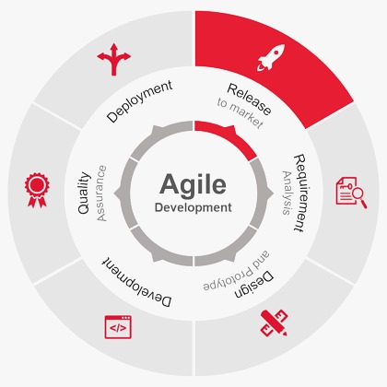

Figure 1.1 Agile Model

* Agile process model will have 3 cycles.
* The outcome of first cycle will be a prototype of basic type with partial functionality.
* After first cycle prototype will be deployed in the field to test the developed functionality. Then it will be evaluated to check the accuracy of system. Based on the results of prototype system, improvements will be made in the second cycle.
* Cycle three will evaluate performance of the second cycle according to required criteria. Any changes needed will be made in third cycle and final release of the system will be made.

Risk Mitigation factor will be used to deal with risks like hardware failure and software compatibility issues.

## Rationale behind Selected Methodology

### Advantages of Agile Model:

* Customer satisfaction by rapid, continuous delivery of useful software.
* People and interactions are emphasized rather than process and tools. Customers, developers, and testers constantly interact with each other.
* Working software is delivered frequently (weeks rather than months).
* Face-to-face conversation is the best form of communication.
* Close, daily cooperation between businesspeople and developers.
* Continuous attention to technical excellence and good design.
* Regular adaptation to changing circumstances.
* Even late changes in requirements are welcomed.

# CHAPTER 2: REQUIREMENT SPECIFICATIONS

In this chapter functional and non-functional requirements along with interfaces (logical) have been provided. This includes specific requirement along with behavioral requirements and contains information about product scope and also users with their roles.

## Product Scope

The recognition accuracy for emotion-based recognition system for berlin speech can be increased/ improved by increasing the number of samples. Further standardization of these speech samples become necessary so that more researchers can innovatively put efforts in this area. The present work can extend for text independent speech also. Can be used to determine e mood of physically challenged & mentally challenged Person.

## Product Description

### Product Perspective

We have dataset which will classify the emotions on base of voice.. This dataset is publicly available on internet and it is free to use. We have selected the dataset which is best and suitable to our model by which our model’s prediction accuracy could be efficient. The dataset we have chosen for our product, firstly we have cleaned our dataset so that word features could be clearly identified. After cleaning raw data, we have extracted important features from cleaned raw data. As our features are extracted, now it’s time for training out model. Now on extracted feature set our model would be trained. Now our model is trained and ready to be implemented. User interface is designed for the ease of user, so that user can interact with the system easily. User will input any query and related to that query features would be extracted from user’s input. When feature extraction process is completed now those extracted feature set could be passed to our trained model. Our trained model will apply processing and predict results which would be accurate enough. After prediction, the results related to the user’s input would be displayed on charts so that user can understand the results. 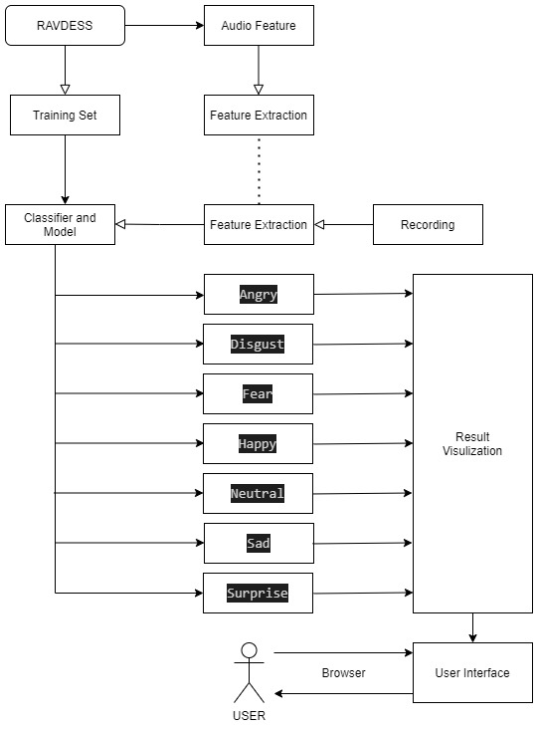

Figure 2. Product perspective

### 

### Product Functionality

* Predicts percentage of emotions on voice..
* Enables user to predict emotions.
* Dataset and efficient model updated by admin.

### Users and Characteristics

There is only one user:

* User

User will only be able to record their voice in the algorithm where he or she can speak in any way. After that he will get visualize form of results by which he could easily understand the predications those visualization could be multiple graphs like pie chart, bar chart and etc.

### Operating Environment

Operating System Window 10

Processor CPU @ 2.90GHz 2.90 GHz

Installed RAM 6.00 GB

Storage 2.00 GB

Installed Program Python, Jupuyter Notebook,anaconda,visual studio code and Tensorflow

Table 2. Operating Environment

## Specific Requirements

### Functional Requirements

* Emotions will be detected according to the voice of the user.
* After detection 7 emotions will show the feeling of the person.
* The charts and comparison of the article would be done according to emotions.
* The user is provided with interactive dashboard which enables the user to view and understand the prediction.

### Behavioral Requirements

Admin:

* Update dataset.
* Design model.
* Train model on maximum values.

User:

* Record voice
* View result.

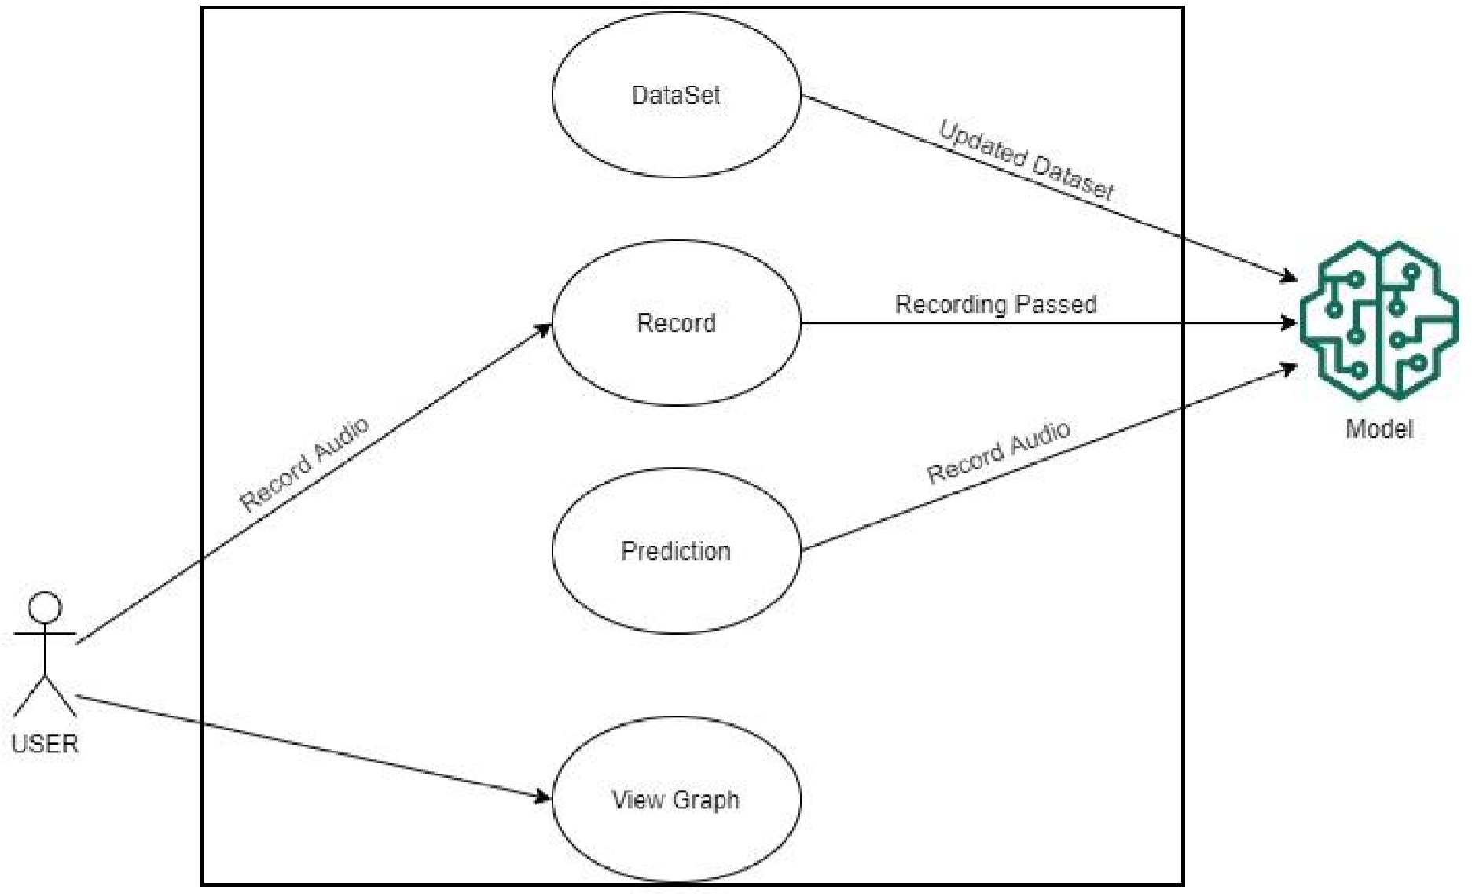

Figure 2. Use Case Diagram

### External Interface Requirements

#### User Interface

There will be various screens available to user. 1st of all there is a button in the 1st page where you can click and starts the emotions. After that start recording button will appear by clicking on that recording will start to record for 10 seconds. Next screen after recording voice will display the result in form of graphs and emojis. Then we get the emotions of the person.

## Non-functional Requirements

### Reliability Requirements

The reliability of the product will be dependent on the accuracy of the data. How much accurate and precise results our model would predict but product would be reliable as model could be updated with passage of time.

### Safety and Security Requirements

No security or safety strategy is required while using this website. Our system is for emotion detection purposes so it provides authentic and accurate information. It is designed as open-source learning platform so no personal information is requested from the user before use. Therefore, using this product is completely safe and secure.

### Portability

This application is completely portable and the recommendations completely trustworthy as the data is dynamically updated.

### Software Quality Attributes

* It takes less time to search results about the particular query user searched for.
* Interface of the application is easy to use and understand.

# CHAPTER 3: DESIGN SPECIFICATIONS

A design specification is a detailed document providing a list of points regarding a product or process. For example, the design specification could include required dimensions, environmental factors, ergonomic factors, aesthetic factors, maintenance that will be needed, etc. A design approach is a general philosophy that may or may not include a guide for specific methods. Some are to guide the overall goal of the design. A combination of approaches may be used if they don’t conflict.

## Introduction

In our software, a structured design approach has been used. Structured design approaches make a complete structure of the system that can be divided into different modules. Modules can be developed separately and then they can be integrated into a structure. All the modules interrelate with each other. This approach is based on the "divide and conquers" rule. The problem is divided into small problems. Each problem is solved individually. In the end, these solutions are linked into a hierarchy.

## System Design

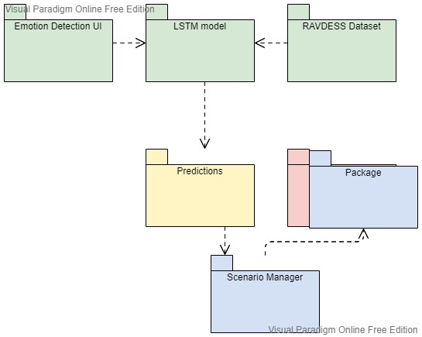

Figure 3.1 Package Diagram

## Logical Viewpoint

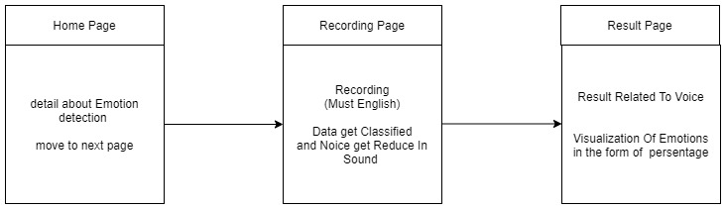

Figure 3. Class Diagram

## System Interaction and Use Cases

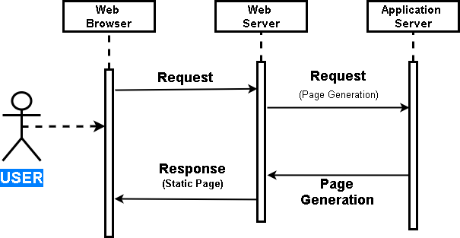

Figure 3.3 Sequence Diagram

## System Architecture

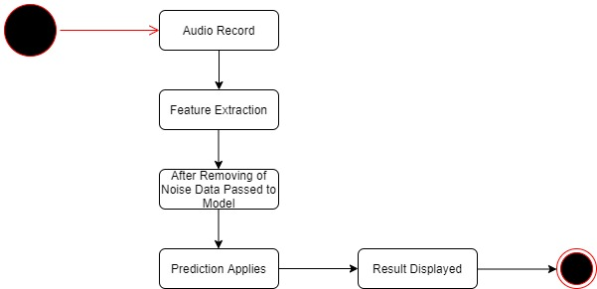

Figure 3. UML Diagram

## Algorithmic Viewpoint

We have used CNN with LSTM. Whenever user record audio it will pass to the train model for predict the emotions of the user and give emotion label. And it applies computation on the audio and predicts result. The predicted results are displayed using charts so that it can be understandable by user easily.

Step 1; Open Anaconda prompt

Step 2: Go to the directory where our project is placed

Step 3: Type flask run

Step 4: Then copy URL address

Step 5: Type on start recording button.

Step 6: Then type on Analysis emotion button.

# CHAPTER 4: DEVELOPMENT AND TOOLS

Development tools can be of many forms like linkers, compilers, code editors, GUI designer, assemblers, debugger, performance analysis tools etc. There are certain factors to be considered while selecting the corresponding development tool, based on the type of the project. In our project, development tools we used HTML are Jupyter Notebook. HTML is used for developing front end and back end of our application. While, Jupyter Notebook is used for developing model by which we will predict results.

## Introduction

First of all, we will train our model on publicly available dataset and then we will test the model on real-time based dataset which will be recorded from the voice of user and the recorded data will be preprocessed and then we will test our model with preprocessed dataset. When the model is trained and able to detect Emotions in the content, we will make the model to able to retrieve the latest data from the voice of user and predict amount of emotions. The amount of emotions will be represented by a graph such that we can clearly measure emotions in the content.

## Development Plan

This project is developed by a team of two members.

1. HAMID REHMAN (FA17-BCS-121)
2. MUHAMMAD DANISH (FA17-BCS-058)

|  |  |  |
| --- | --- | --- |
| **Student Name** | **Student Registration Number** | **Responsibility/ Modules** |
| HAMID REHMAN  MUHAMMAD DANISH | FA17-BCS-121  FA17-BCS-058 | Hamid Rehman (Documentation, Back End, Deep Learning)  M. Danish (Documentation, Front End) |

Table 4. Development Plan 1

|  |  |  |  |  |
| --- | --- | --- | --- | --- |
| **Emotions Detection Through Speech** | | | | |
| COMSATS UNIVERSITY ISLAMABAD VEHARI CAMPUS | | | | |
| Project Lead: | |  | Start Date | End Date |
| Hamid Rehman | M.Danish |  | 1/10/2020 | 06/06/2021 |
| **TASK** | **PROGRESS** | **START** | **END** | **Duration Days** |
| **Analysis** |  |  |  |  |
| Discussion | 100% | 1/10/2020 | 20/10/2020 | 20 |
| Paperwork | 86% | 21/10/2020 | 30/10/2020 | 10 |
| Documentation of system | 95% | 31/10/2020 | 31/11/2020 | 20 |
| Analysis complete | 100% | 01/12/2020 | 20/12/2020 | 20 |
| **Design** |  |  |  |  |
| Design Dashboard | 90% | 21/12/2020 | 20/01/2021 | 20 |
| Interface Design | 96% | 21/01/2021 | 25/02/2021 | 30 |
| **Development** |  |  |  |  |
| Build Model | 100% | 20/03/2021 | 15/04/2021 | 25 |
| Train Model | 100% | 15/04/2021 | 31/04/2021 | 15 |
| Take Prediction |  | 31/04/2121 | 05/05/2021 | 10 |
| Development Complete | 99% | 05/05/2021 | 31/05/2021 | 05 |
| **Testing** |  |  |  |  |
| Perform System Testing | 95% | 31/05/21 | 03/06/2021 | 05 |
| **Project Completed!** |  | 06/06/2021 |  | 180 |

Table 4. Gantt Chart

## Development Tools

|  |  |  |
| --- | --- | --- |
| **Tools**  **And**  **Technologies** | **Tools** | **Rationale** |
| Visual Code | IDE |
| MS Word | Documentation |
| Jupyter Notebook | IDE |
| **Technology** | **Rationale** |
| Python | Programming language |
| Flask | Web Framework |
| HTML | Web Development |
|  |  |  |

Table 4. Development Tools and Technologies

## Conclusion and Future Work/Extensions

In this project, we presented an automatic speech emotion recognition (SER) system using

machine learning algorithm LSTM and CNN to classify seven emotions. we study how classifiers and features impact recognition accuracy of emotions in speech. A subset of highly discriminant features is selected. Feature selection techniques show that more information is not always good in machine learning applications. The machine learning models were trained and evaluated to recognize emotional states from these features. The effect of training multiple emotion detectors can be investigated by fusing these into a single detection system. We aim also to use other feature selection methods because the quality of the feature selection affects the emotion recognition rate: a good emotion feature selection method can select features reflecting

emotion state quickly. The overall aim of our work is to develop a system that will be used

in a pedagogical interaction in classrooms, in order to help the teacher to orchestrate his

class. For achieving this goal, we aim to test the system proposed in this work.

## User Interfaces

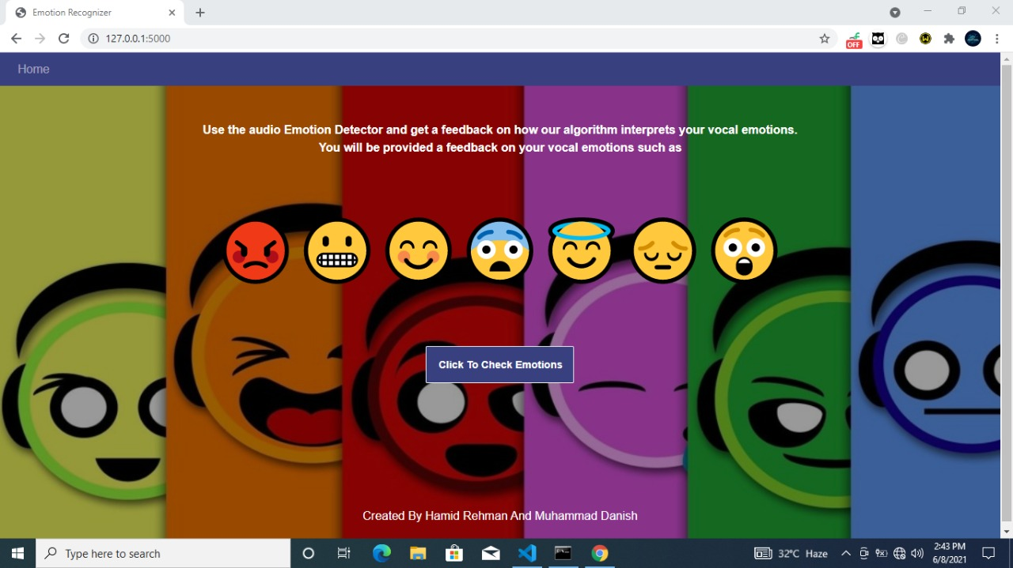

Figure 4. Check Emotions

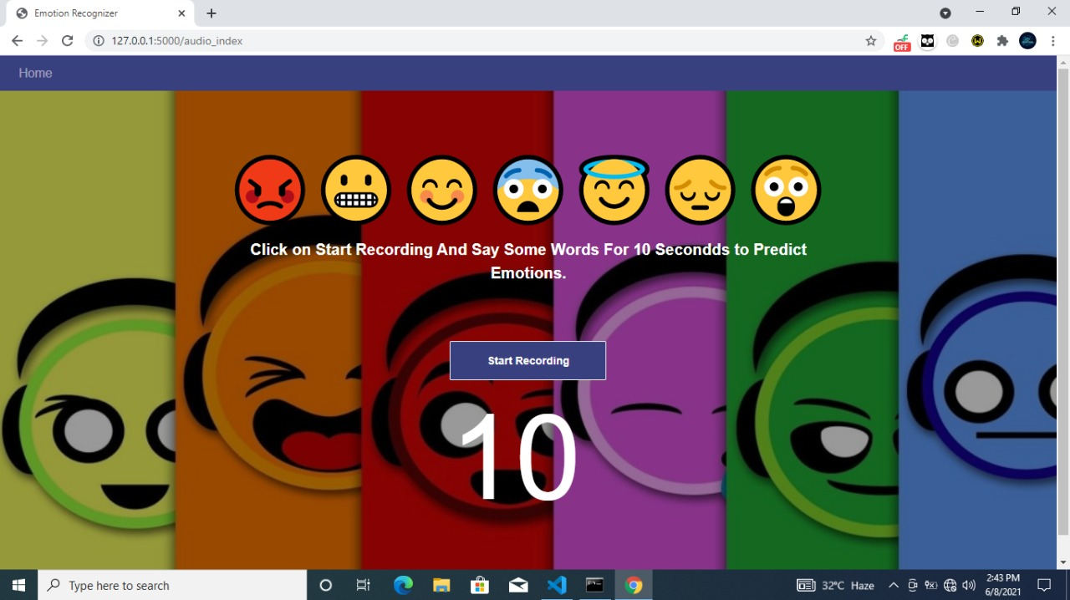

Figure 4. Start Recording

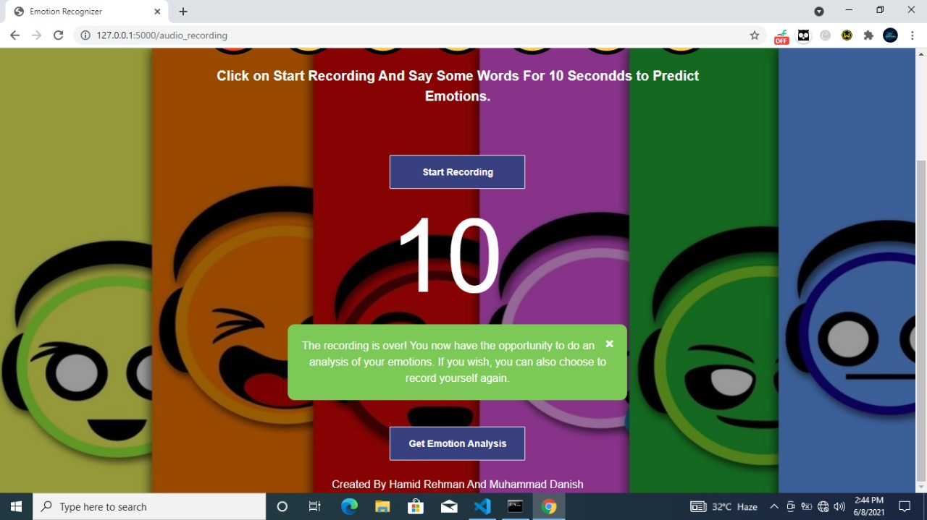

Figure 4. Emotion Analysis

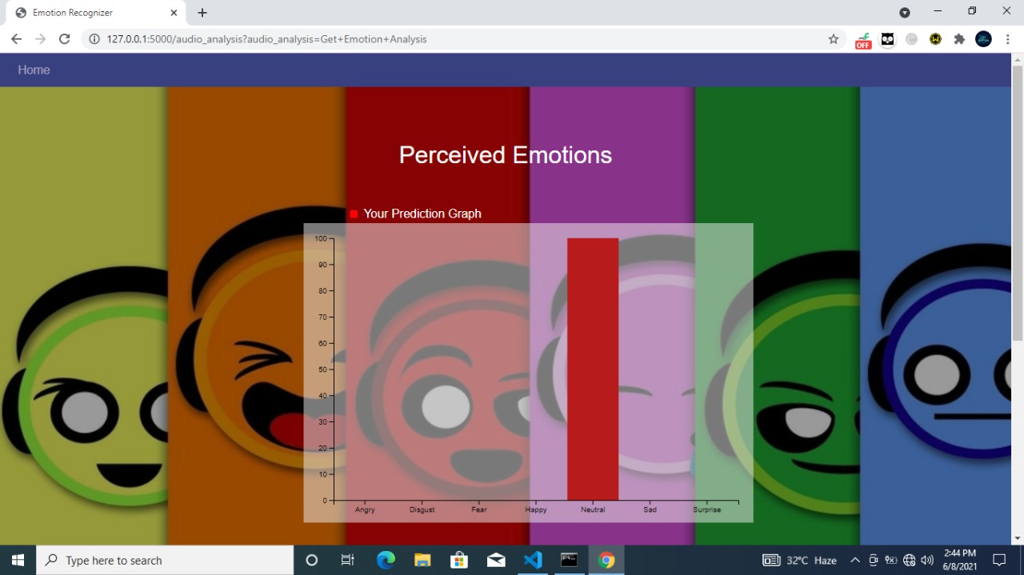

Figure 4. Graph Result

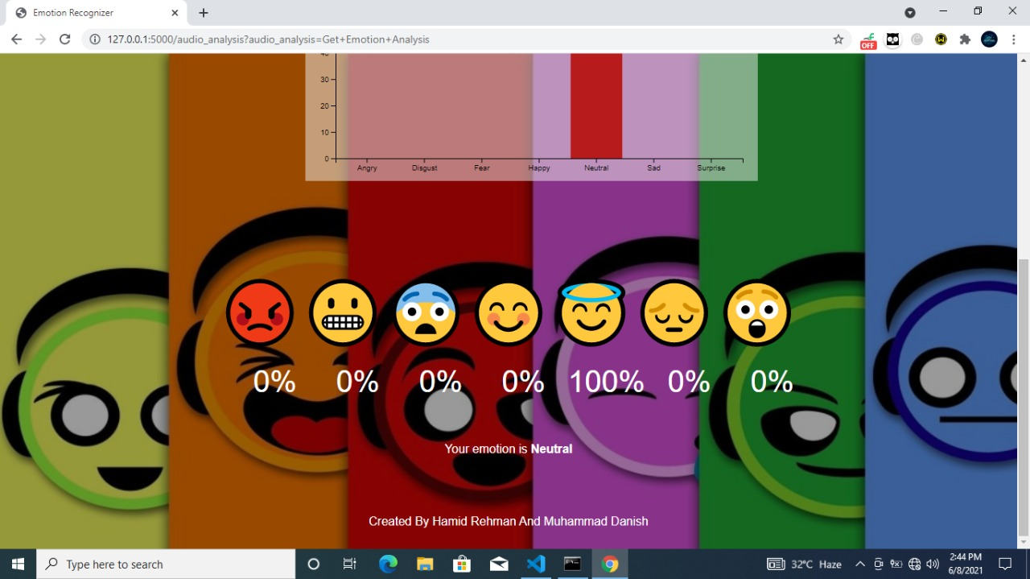

Figure 4. Emoji Result

# CHAPTER 5: QUALITY ASSURANCE

Quality assurance (QA) is a way of preventing mistakes and defects in manufactured products and avoiding problems when delivering products or services to customers; which ISO 9000 defines as "part of quality management focused on providing confidence that quality requirements will be fulfilled". It is systematic process used to determine if a product or service meets quality standards.

## Introduction

In quality assurance phase which is mainly based on Test plan including testing strategies and types of testing applied to ensure the reliability and accuracy of the application to give the user a great and error free learning experience. Since satisfaction of end user is a first and foremost priority, thus to ensure it, a proper testing mechanism was devised and the results are tabulated in the form of test cases and to trace each test case against desired functional requirement a requirement traceability matrix have been devised which include test case ID against each and every functional requirement desired by user.

## Traceability Matrix

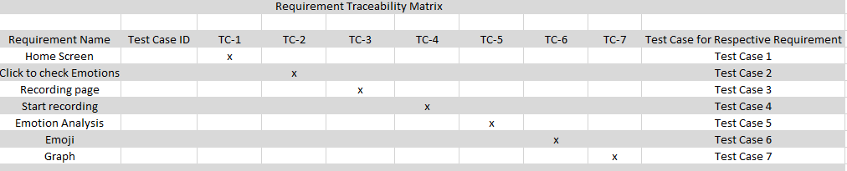

Table 5.1 Traceability Matrix

Table 6 Traceability Matrix

## Test Plan

|  |  |
| --- | --- |
| Test ID | TC-1 |
| Test name | Application Startup |
| Date of test | 05/06/2021 |
| Name of application | Emotion Detection Through Speech |
| Description | Home screen will be displayed where user will search for any emotion. |
| Input | Run app using link. |
|  |  |
| Expected output | Home screen will be displayed |
| Actual output | Home screen displayed |
| Test Role (Actor) | Hamid Rehman |
| Test verified by | Muhammad Danish |

Table 5. Test Case for Application Startup

|  |  |
| --- | --- |
| Test ID | TC-2 |
| Test name | Application Recording |
| Date of test | 05/06/2021 |
| Name of application | Emotion Detection Through Speech |
| Description | Home screen will be displayed where user can click and redirect to the recording page. |
| Input | Button click |
| Expected output | It will be redirected to the recording page. |
| Actual output | Redirected to recording page |
| Test Role (Actor) | Hamid Rehman |
| Test verified by | Muhammad Danish |

Table 5. Test case for Application Recording

|  |  |
| --- | --- |
| Test ID | TC-3 |
| Test name | Application Recording page |
| Date of test | 05/06/2021 |
| Name of application | Emotion Detection Through Speech |
| Description | Recording screen will be displayed. |
| Input | Button will be clicked |
| Expected output | Start recording page will be displayed |
| Actual output | Recording page will be displayed |
| Test Role (Actor) | Hamid Rehman |
| Test verified by | Muhammad Danish |

Table 5. Test Case for Application Recording Page

|  |  |
| --- | --- |
| Test ID | TC-4 |
| Test name | Application start recording page. |
| Date of test | 05/06/2021 |
| Name of application | Emotion Detection Through Speech |
| Description | Result screen will be displayed where user can record their voice. |
| Input | By clicking on button recording will start. |
| Expected output | Voice will be recorded. |
| Actual output | Voice recorded |
| Test Role (Actor) | Hamid Rehman |
| Test verified by | Muhammad Danish |

Table 5. Test Case for Application Start Recording

|  |  |
| --- | --- |
| Test ID | TC-5 |
| Test name | Application prediction |
| Date of test | 05/06/2021 |
| Name of application | Emotion Detection Through Speech |
| Description | Result screen will be displayed where user will get predication in multiple graphs and emojis. |
| Input | Type any keyword to display relative emotion prediction graphs. |
| Expected output | Graphs and emoji will be displayed |
| Actual output | Graphs and emojis displayed |
| Test Role (Actor) | Hamid Rehman |
| Test verified by | Muhammad Danish |

Table 5. Test Case for Application Prediction

|  |  |
| --- | --- |
| Test ID | TC-6 |
| Test name | Application Emoji will display |
| Date of test | 05/06/2021 |
| Name of application | Emotion Detection Through Speech |
| Description | Emojis will be displayed on result screen. |
| Input | Recording |
| Expected output | Emojis will be displayed |
| Actual output | Emojis displayed |
| Test Role (Actor) | Hamid Rehman |
| Test verified by | Muhammad Danish |

Table 5. Test Case for Application Emoji

|  |  |
| --- | --- |
| Test ID | TC-7 |
| Test name | Application graph will display |
| Date of test | 05/06/2021 |
| Name of application | Emotion Detection Through Speech |
| Description | Graph will be displayed on result screen. |
| Input | Recording |
| Expected output | Graph will be displayed |
| Actual output | Graph displayed |
| Test Role (Actor) | Hamid Rehman |
| Test verified by | Muhammad Danish |

Table 5. Test Case for Application Graph

# References

* Rodrigues, M.F., Gonçalves, S.M., Santos, R., Fdez-Riverola, F., Carneiro, D.: Intelligent Tutoring: Active Monitoring And Recommendation. In: Interdisciplinary Perspectives on Contemporary Conflict Resolution, pp. 205–224. IGI Global (2016)

Google Scholar.

* Carneiro, D., Rocha, H., Novais, P.: An environment for studying visual emotion perception. In: International Symposium on Ambient Intelligence, pp. 238–245. Springer, Cham, June 2017

Google Scholar.

* Kandali, A.B., Routray, A., Basu, T.K.: Comparison of features based on MFCCs and Eigen values of autocorrelation matrix for cross-lingual vocal emotion recognition in five languages of Assam. In: IEEE India Conference (INDICON), 2009 Annual IEEE [S.l.], pp. 1–4 (2009)

Google Scholar.

* Alim, S.A., Rashid, N.K.A.: Some commonly used speech feature extraction algorithms. In: From Natural to Artificial Intelligence-Algorithms and Applications. IntechOpen (2018)

Google Scholar.

* Eyben, F., et al.: Recent developments in openSMILE, the munich open-source multimedia feature extractor. In: Proceedings of ACM Multimedia 2013, pp. 835–838. ACM, Barcelona (2013)

Google Scholar

* El Ayadi, M., Kamel, M.S., Karray, F.: Survey on speech emotion recognition: features, classification schemes, and databases. Pattern Recogn. 44(3), 572–587 (2011)

zbMATHCrossRefGoogle Scholar.